Integrated Solid Oxide Systems: Advancing Efficiency in Power Generation through Fuel Cell-Electrolyzer Coupling with Diverse Fuels
Xinyi Wei^{a,b}, Shivom Sharmaª, Arthur Waeberª, Jan Van Herle^{b}, Francois Marechalª
ªIPESE, EPFL Valais Wallis, 1950 Sion, Switzerland
^{b}GEM, EPFL Valais Wallis, 1950 Sion, Switzerland
xinyi.wei@epfl.ch
Abstract
The significant increase in CO₂ concentrations in the atmosphere, which is primarily caused by the combustion of fossil fuels for electricity production. Situated as an auspicious candidate in the realm of environmentally friendly energy and heat generation, the solid oxide fuel cell (SOFC) assumes a pivotal role in confronting this pressing challenge. Usually, owing to the fact that SOFC does not achieve a 100% fuel conversion rate, unconverted fuel is combusted into a burner, and resulting gases are released into the environment. Air is commonly employed in this combustion process. However, the challenge arises when using carbon-based fuels, as the presence of nitrogen makes it challenging to capture CO₂ at downstream of the burner. In this study, an innovative system has been introduced. Solid oxide electrolyzer cells (SOEC) is coupled with SOFC. The novel SOFC-EC configuration achieves a remarkable 100% CO₂ capture rate and purity when utilizing natural gas. Additionally, hydrogen as an alternative SOFC fuel has been considered. A comprehensive performance analysis has been conducted with these two distinct fuels. The evaluation incorporates multi-objective optimization, encompassing various design parameters to provide a comprehensive understanding of the system's capabilities. The active area demand for SOEC is exceptionally low, comprising a mere 4.3% of the active area required for SOFC, all the while attaining a system efficiency close to 60% and adhering to all industrial constraints. With its long-term viability, this innovative SOFC-EC system arises as a promising, compact and cost-effective solution. Significant potential exists for it to influence the course of power generation towards greater sustainability and cleanliness.
Keywords: Solid Oxide Fuel Cell, Solid Oxide Electrolyzer, Carbon Capture, Oxy-combustion, Anode Off-gas Recirculation.
  - Introduction
Solid oxide fuel cells (SOFC) have emerged as a focal point of scientific attention, showcasing promising potential as a power generation technology that could reduce dependence on traditional electricity grids. Their compact design with external fuel storage and its fuel inputs flexibility enhances their adaptability for application in diverse industrial power plants (Sharma et al., 2018). Notably, SOFC operate at elevated temperatures, reaching up to 800°C, enabling the co-generation of high-quality heat or steam that can be efficiently integrated into the system as a valuable heat source (Sharma et al., 2019). Despite their advantages, SOFC face a challenge with a maximum fuel utilization rate of approximately 85%. To address this, a burner is employed to combust any unconverted fuels. While serving the dual purpose of supplying supplementary heat to the SOFC system, the burner introduces an additional aspect by generating additional CO₂. A potential solution involves the direct injection of pure oxygen into the burner. However, this approach brings its own set of challenges, particularly the need for specialized O₂ tanks or production units, such as membrane separation systems, which can be both energy-intensive and costly to implement. Moreover, the production and supply chain of oxygen would require meticulous organization, especially if it is produced at a centralized facility. Solid oxide electrolyzer cell (SOEC), is able to produce O₂ as a byproduct, which can be efficiently utilized in a catalytic burner for the complete combustion of fuel. The flexibility to adjust the quantities of CO₂ and water allows for precise control over the amount of O₂ produced by the electrolyzer. This level of control facilitates a meticulous regulation of the combustion process, leading to the generation of only CO₂ and water, and water can easily be condensed.

In this study, a novel process integration has been thoroughly examined by coupling of SOFC and SOEC. Two distinct types of fuels have been chosen for investigation: natural gas and H₂. The selection of natural gas is driven by the system's ability to easily capture CO₂, presenting an advantageous solution. On the other hand, the inclusion of hydrogen as a fuel allows for a comprehensive understanding of the system's compatibility with different energy carriers. The outcomes of this analysis not only shed light on the suitability of the proposed system for diverse fuel types.
  - Methodology
    - SOFC – SOEC system description
This integrated SOFC-EC system is shown in Figure 1, where the incoming fuel - whether natural gas or H₂ - is preheated in H1. To prevent carbon deposition, especially in the case of natural gas, a specific steam-to-carbon ratio must be maintained, therefore, external water is heated in heater H2. Subsequently, the mixture of fuel and steam undergoes further heating in H3 before being introduced into an external reformer. Within the reformer, steam methane reforming occurs, converting a portion of CH₄ into CO and H₂. This step is crucial as it avoids carbon deposition in the fuel cell, particularly when relying solely on internal reforming. It is important to note that when the fuel is H₂, the need for external water or reformer is eliminated. The syngas or H₂ is heated to the necessary SOFC inlet temperature in H5. In SOFC, the chemical energy is converted into electricity.

The anode off-gas (AOG), from the anodic downstream side of SOFC, has three potential routes. Firstly, the AOG can be recirculated back to the inlet of the external reformer after water condensation via C2 and C3. This option requires a low-temperature AOG compressor to overcome the pressure drops of the reformer, heat exchangers and stack. Secondly, a potential approach involves partial use of AOG as the inlet to the SOEC, where (co-) electrolysis reactions occur, converting CO₂ and/or steam into CO and/or H₂. Given the similar operating temperatures of the SOFC and SOEC, the advantage lies in the elimination of an additional heat exchanger. The syngas/H₂ produced by SOEC is injected back into the external reformer. Thirdly, the remaining AOG flow is directed to the burner to undergo oxy-combustion, utilizing the oxygen produced from the anodic side of the SOEC. The flue gases at downstream of the burner undergo cooling in C4 and C5 before entering into a water separator/condenser. Notably, when natural gas is used as the fuel and pure O₂ is employed, the process facilitates straightforward carbon capture.
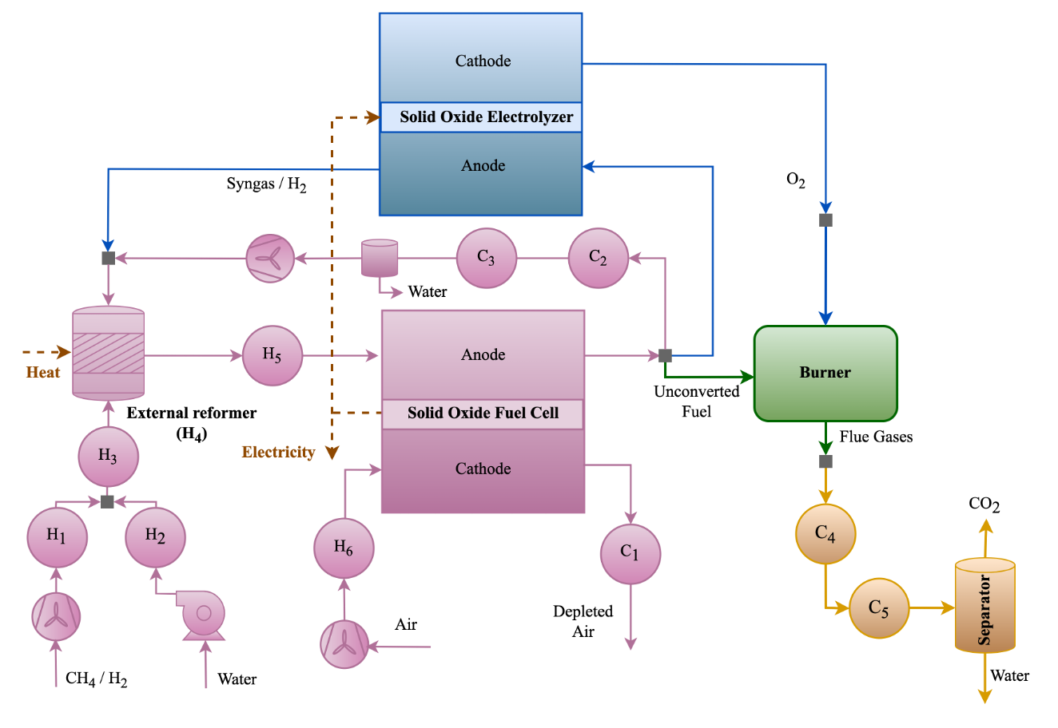
Figure 1. Novel SOFC-SOEC system with oxy-combustion and water separator
The process flowsheet has been simulated in Aspen Plus V12.0, and the key simulation parameters are presented in Table 1. The SOFC system presented has a capacity of 10 kW. The efficiencies of the AOG blower or air blower are derived from the commercial products. Although SOEC is chosen to operate at endothermic or thermally neutral mode based on previous studies.
Table 1. Specifications of SOFC and SOEC systems (T - temperature, P - pressure)
SOFC System: Stack area ~ 3 m², Stack P drop = 0.08 bar, Maximum stack ΔT = 100 °C, Stack outlet T = 750 °C, Current density = 4000 A/cm², Air blower suction P, P increase, efficiency = 1 bar, 0.3 bar, 0.8
SOEC System: Stack inlet T = 800 °C, Conversion efficiency = 0.9, Operating mode = Thermal neutral, Stack outlet T = 800 °C, Single pass fuel utilization = 0.9, Electricity to H₂ efficiency = 0.95
    - Multi-objective Optimization Problem
The multi-objective optimization (MOO) problems formulated were solved using OSMOSE, a decision-making tool developed within our research group. Figure 2 illustrates the basic flowchart depicting the working principle of OSMOSE. Dakota has been used as an external MOO tool to solve the complex optimization problems. OSMOSE is linked with process flowsheet in Aspen Plus to transfer decision variable values and retrieve essential data from the process model. A mixed-integer linear programming (MILP) problem is formulated, utilizing process and utility models to optimize interconnections, mass flows, and heat flows. The MILP problem is then solved using the AMPL/CPLEX solver. Table 2 provides a list of objective functions, decision variables along with their specified ranges, and constraints with set limits. The selection of decision variable ranges and constraint limits is based on the existing literature.
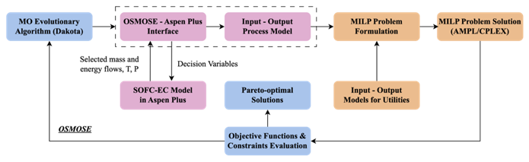
Figure 2. Mechanism of OSMOSE: A Tool for Process Integration and Optimization
Table 2. Objective Functions, Decision Variables and Constraints Information
Objective Functions: F1 - Max Electrical efficiency (%), F2 - Max Global Fuel Utilization (FU), F3 - Min Single Pass FU, F4 - Max the ratio of Global FU/Single FU, F5 – Max Heat Available at 600 °C
Decision Variables with Lower and Upper Limits (CH₄ / H₂ case): External Reforming Temperature (CH₄ case) = 510-550 °C, External Reforming Ratio (CH₄ case) = 0.1 – 0.5, Fuel Input (CH₄ case) = 0.0155 – 0.02 mol/s, External Water Flow (CH₄ case) = 0.1 – 0.09 mol/s, Fuel Input (H₂ case) = 0.0595 – 0.1 mol/s, AOG Recirculation Ratio = 0 – 0.9, SOEC power input = 0.1 – 4 kW
Constraints with Limits: S/C (CH₄ case) > 1.5, Burner Downstream O₂ mole fraction < 0.02, Burner Downstream O₂ mole fraction > 0.00001, ΔT across stack < 100 °C, 0.9 > Single Pass FU > 0.2
  - Results and Discussions
    - System performance analysis
      - CH₄ as SOFC fuel input
The performance of the proposed system has been examined using CH₄ fuel. Figure 3(a) illustrates the outcomes of MOO, considering system electrical efficiency, the ratio between global FU and single pass FU, and the available heat at 600 °C as three objectives. The results reveal a notable trend: as the system electrical efficiency increases, the difference between global FU and single FU becomes smaller. This indicates that a lower AOG recirculation rate is required, a sensible outcome considering the power consumption by the AOG blower. Similarly, for high AOG recirculation, cooling and water removal increase to reduce the AOG blow power consumption. However, this cooling process leads to inefficient use of system heat, resulting in a higher ratio between global and single FU and a smaller amount of high-temperature available heat. In summary, when considering these three objectives, the analysis suggests that the maximum system electrical efficiency achievable is approximately 54%. Transitioning to Figure 3(b), the distinction in this scenario lies in the exclusion of available heat from MOO problem. Beyond the observed conclusions, it is intriguing to note that the achievable system electrical efficiency is approximately 56%, surpassing the efficiency obtained in the previous case.
      - H₂ as SOFC fuel input
As depicted in Figure 4 (a), similar conclusions can be drawn when considering H₂ fuel. The maximum achievable system electrical efficiency is approximately 52%. This efficiency is slightly lower compared to CH₄ case. The difference arises from the internal reforming that occurs for CH₄. This internal reforming requires heat, which aids in reducing the air flow rate as it is employed to control the maximum stack outlet temperature. In case of H₂, the reaction is strongly exothermic, resulting in a higher power requirement by the air blower, leading to reduced overall electrical efficiency. When using H₂ fuel, AOG only contains H₂ and steam. This means that after AOG condensation, the flow predominantly consists of H₂ with a small portion of water. If high recirculation is applied, it can lead to a situation where the system has a very low single pass FU, while the global FU remains high. This characteristic is highlighted by the range of these two FUs ratio, with the maximum ratio reaching 2 for H₂ case and 1.3 for CH₄ case. This finding is further supported by Figure 4 (b). After removing F5, the system maximum efficiency can reach nearly 58%, whereas single FU is less than 0.3.

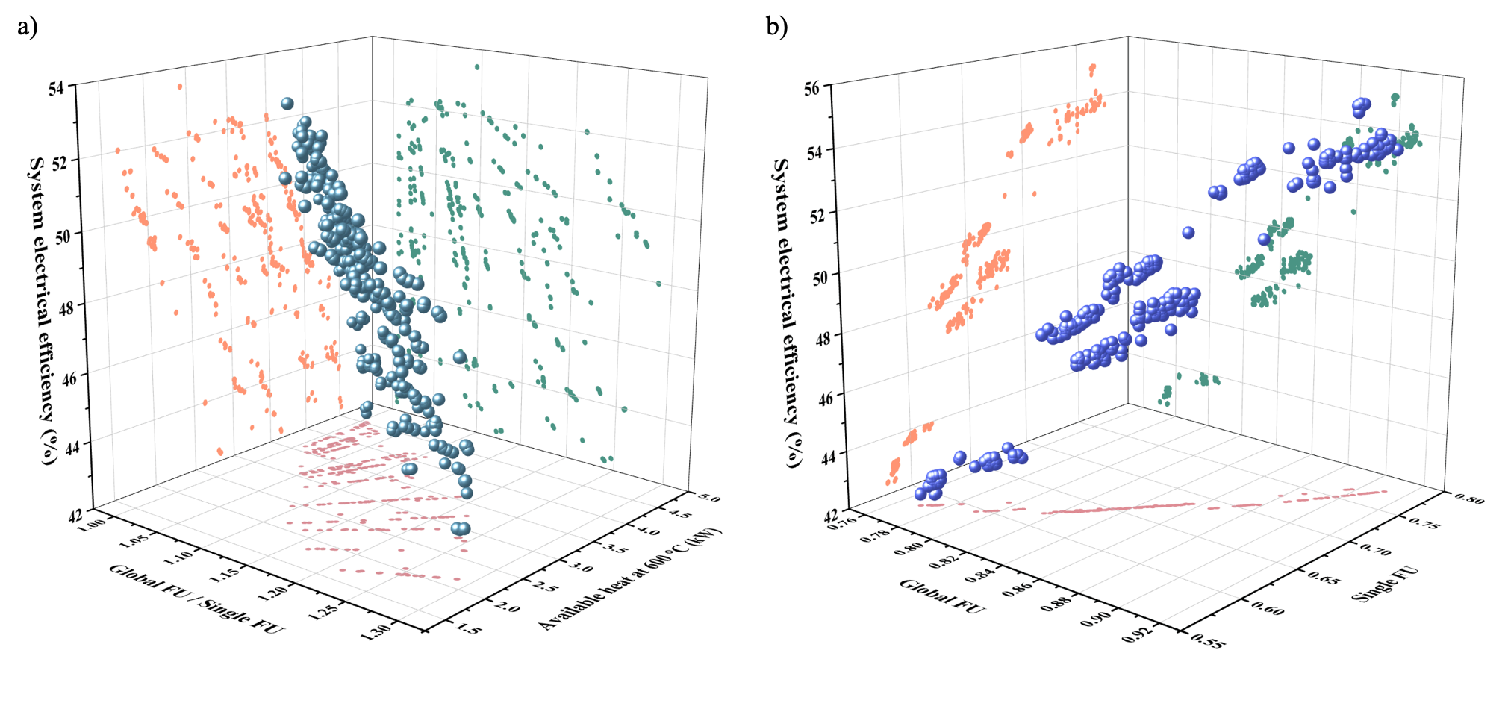
Figure 3. MOO performance analysis by using (a) F1, F4 and F5, (b) F1, F2 and F3.
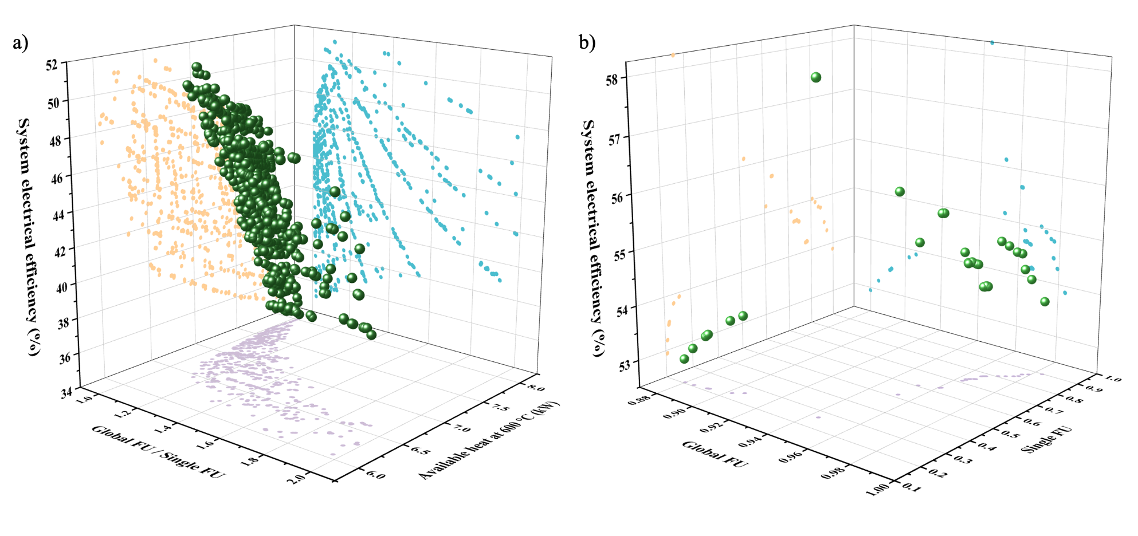
Figure 4. MOO performance analysis by using (a) F1, F4 and F5, (b) F1, F2 and F3.
    - Process design parameters analysis
      - CH₄ as SOFC fuel input
Figure 5 illustrates various relationships between different decision variables and F1 and F5. As anticipated, a lower AOG recirculation rate corresponds to a higher available high-temperature heat. When the efficiency exceeds 52%, the AOG ratio predominantly remains above 0.4. Interestingly, the system can achieve the same efficiency, with different set of parameter values. Additionally, lower external water usage is associated with less heat consumed to convert water into steam. Higher external water usage, indicating a relatively low AOG, tends to result in a slightly lower efficiency. The trend for SOEC power input is clear - higher SOEC input power is linked to lower efficiency. The external reforming temperature, reforming ratio and fuel input flow rate do not have any clear trends. Different combinations of these design parameters can yield similar objectives. However, the system does exhibit a preference for lower external reforming temperature (510 °C), a ratio of 0.2, and a fuel input flow rate less than 0.0165 mol/s.
      - H₂ as SOFC fuel input
As illustrated in Figure 6, H₂ fuel case has similar conclusions. In CH₄ case, AOG contains LHV compositions (CO and even CO₂); in H₂ fuel case, higher AOG recirculation can indeed bring benefits in efficiency, especially when exceeding 0.56. Regarding fuel input, no clear trend can be observed, consistent with previous observations. However, the system does demonstrate a preference for lower fuel input. Conversely, for SOEC, a lower power input is associated with higher efficiency but poorer performance in terms of high-temperature available heat.
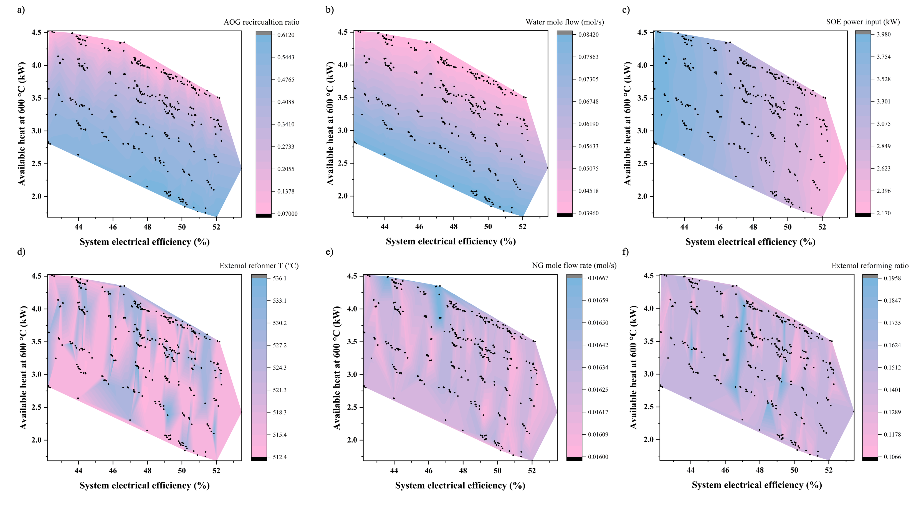
Figure 5. Variation in design parameters with objective functions F1 and F5.
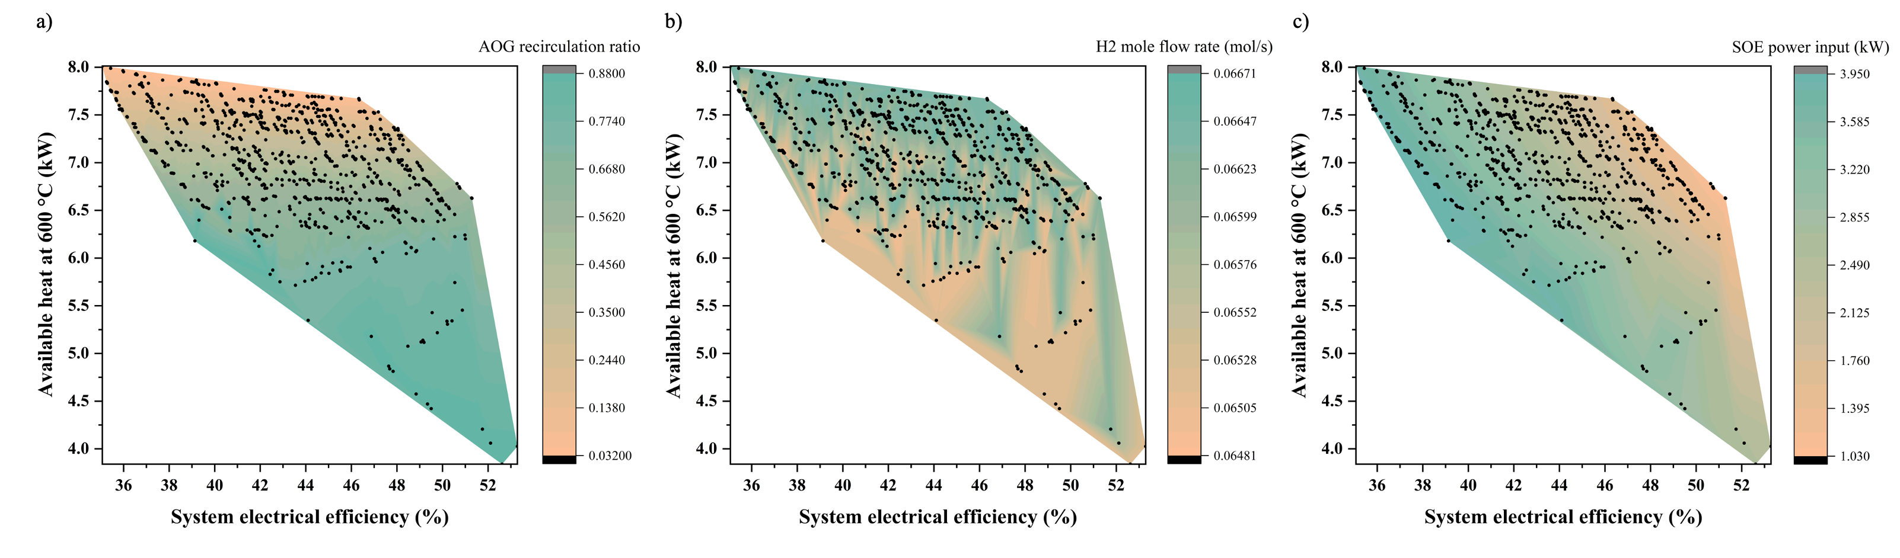
Figure 6. Variations in design parameters with objective functions F1 and F5.
  - Conclusions
In this study, an innovative approach was undertaken to couple SOFC and SOEC, examining two distinct fuel inputs, CH₄ and H₂. The outcomes unveiled subtle patterns in system performance, where factors such as AOG recirculation, external water usage and input power played pivotal roles in shaping efficiency and high-temperature available heat. Particularly noteworthy was the H₂ fuel case, showcasing that elevated AOG recirculation could elevate efficiency to levels surpassing 58%, excluding waste heat valorization. In the CH₄ fuel case, the system achieved a maximum efficiency of around 56%, featuring automatic CO₂ capture. These results underscore the promising prospects of the modular SOFC-EC system.
References
S. Sharma and F. Maréchal, “Robust Multi-Objective Optimization of Solid Oxide Fuel Cell–Gas Turbine Hybrid Cycle and Uncertainty Analysis,” J. Electrochem. Energy Convers. Storage, vol. 15, no. 4, p. 041007.

